**Implementation Of Personal Fitness Tracker Using Python**

A Project Report

submitted in partial fulfillment of the requirements

of

AICTE Internship on AI Transformative Learning

with

TechSaksham – A joint CSR initiative of Microsoft & SAP

By

**KAVYA ANUPOJU**

[**anupojukavya1603@gmail.com**](mailto:anupojukavya1603@gmail.com)

Under the Guidance of

**Saomya chaudhury**

**ACKNOWLEDGEMENT**

We would like to express our heartfelt gratitude to everyone who contributed to the successful completion of this project, "Implementation of Personal Fitness Tracker Using Python."

We sincerely thank our mentors and professors for their invaluable guidance, encouragement, and expertise in fitness tracking, data analytics, and software development, which played a crucial role in shaping our project. Their support motivated us to explore new ideas, refine our implementation, and enhance our system’s effectiveness.

We also appreciate the online developer communities, open-source contributors, and researchers for providing valuable resources and datasets. Platforms like GitHub, Kaggle, and Stack Overflow broadened our understanding and helped us implement best practices.

A special thanks to technology pioneers and industry leaders whose work in wearable fitness devices and AI-driven health analytics inspired our research and development.

We are grateful to our friends and peers for their constructive feedback, which improved the user experience and functionality of our system.

Finally, we express our deepest gratitude to our families for their unwavering support, patience, and encouragement throughout this journey.

This project is a testament to the collaborative effort and knowledge-sharing that made it a success. We hope it contributes meaningfully to the field of fitness tracking and health technology.

#### **ABSTRACT**

The quick uptake of fitness tracking technology has revolutionized personal health management. This project, "Implementation of Personal Fitness Tracker Using Python," is intended to create a Python-based tracker that allows users to track important health statistics like step count, calories burnt, heart rate, and sleep patterns. Integrating data from wearable devices and user input, the system uses Python frameworks to process information and display insights via a user-friendly dashboard. It uses data visualization, predictive analytics, and recommendation for customized advice to assist users in reaching their fitness goals. Some of the most important features are real-time activity tracking, calorie estimation, sleep tracking, health analytics, and goal-based suggestions. The tracker uses Python libraries like Pandas, Matplotlib, Seaborn, Scikit-learn, and Flask to provide an easy-to-use interface while employing machine learning algorithms to offer customized workout and diet advice.

**TABLE OF CONTENT**

**Abstract I**

**Chapter 1.**  **Introduction 1**

1.1 Problem Statement 1

1.2 Motivation 1

1.3 Objectives 2

1.4 Scope of the Project 3

**Chapter 2.**  **Literature Survey 7**

* 1. Review relevant literature or previous work in this domain…………..7
  2. Mention any existing models, techniques, or methodologies

related to the problem……………………………………………………..7

* 1. Highlight the gaps or limitations in existing solutions and how

your project will address them………………………………………………...8

**Chapter 3.**  **Proposed Methodology........................................................................9**

* 1. System Design……………………………………………………………..9
  2. Requirement Specification………………………………………………...10

**Chapter 4.**  **Implementation and Results………………………………………...12**

* 1. Snap Shots of Result ………………………………………………………13
  2. GitHub Link for Code

**Chapter 5. Discussion and Conclusion…………………………………………14**

5.1 Future Work….....................................................................................14

5.2 Conclusion…………………………………………………………...15

**References** …………………………………………………………………………..16

**LIST OF FIGURES**

|  |  |  |
| --- | --- | --- |
| **Figure No.** | **Figure Caption** | **Page No.** |
|  | Home page | **12** |
|  | Similar Results Page | **13** |

**CHAPTER 1**

**Introduction**

* 1. **Problem Statement**

The project addresses the challenge of real-time and precise fitness tracking, an important factor in personal health and wellness. Sedentary living, poor fitness practices, and the absence of tailored health information lead to increasing health concerns like obesity, cardiovascular diseases, and metabolic disorders. Conventional fitness tracking approaches are based on manual recording or costly wearable technologies, which can be cumbersome, pricey, and less effective in delivering actionable insights.

This is because generic fitness regimes and absence of live feedback end up in erractic progress as well as insufficient motivation. The only use of commercial fitness programs also risks decreasing access due to excessively high monthly payments and invasion of privacy data. Without constant fitness tracking, the individual finds it difficult to continue with an organized and focused means of monitoring health and wellbeing.

Through the use of AI-powered fitness tracking and real-time data analysis, this project seeks to fill these gaps. An accurate, low-cost, and open-source fitness tracking system empowers users to track their activity levels, gain personalized workout and nutrition advice, and remain motivated with data-based insights. This method not only encourages improved health management and goal attainment but also provides a sustainable and flexible solution for a broad audience. With the increasing demand for individualized solutions for health and fitness, this project offers a scalable, intelligent, and affordable option for those wanting to gain mastery over their well-being.

* 1. **Motivation**

It is difficult to lead a healthy lifestyle because of sedentary lifestyles, unhealthy eating, and the absence of tailored advice. Although there are fitness trackers, most are expensive, not customizable, and privacy-invasive.

With the evolution of Python, data analytics, and machine learning, this project seeks to develop an open-source, low-cost fitness tracker that offers real-time activity monitoring, AI-driven suggestions, and easy-to-understand visualizations. By connecting with APIs such as Google Fit and Fitbit, it provides a personalized, data-based method of health tracking, making fitness tracking more accessible, efficient, and user-friendly for everyone.

**Potential Applications and Impact**

**I. Real-Time Activity Tracking:** The tracker offers real-time monitoring of steps taken, calories burnt, heart rate, and sleep activity, keeping users in touch with their exercise goals.

**II. Personalized Health Insights:** Utilizing data analysis and machine learning, the system provides personalized exercise and eating tips depending on user activity levels and exercise objectives.

**III. User Accessibility:** The web-based and mobile-friendly, intuitive platform allows easy tracking of fitness for users from every walk of life, with or without technical knowledge.

**IV. Improved Health & Lifestyle:** The daily tracking of activity and the AI-based insights urge users towards healthier living, which, in turn, results in overall improved well-being.

**V. Scalability & Integration:** The system can be scaled to add more health indicators, fitness programs, and wearable device partnerships such as Google Fit and Fitbit to support versatility for different user requirements.

* 1. **Objective**

The goal of the "Implementation of Personal Fitness Tracker Using Python" project is to implement a real-time, easy-to-use fitness tracking system that enables users to monitor and enhance their health efficiently. The system uses data analytics, machine learning, and wearable device integration to deliver personal insights, activity monitoring, and health suggestions. This will promote healthier lifestyles, enhanced fitness levels, and enhanced management of life.

**Major Goals:**

1. **Activity Tracking:** Monitor and monitor important health factors like steps counted, calories burnt, heart rate, and sleeping patterns.
2. **Instant Tracking:** Render real-time alerts on body activity to assist customers in remaining well-informed on their fitness regimes.
3. **Data Insights & Visualization:** Employ the utilization of graphs and charts in an effort to indicate health patterns as well as how they progress.
4. **Personalized Feedback:** Provide recommendations on fitness as well as food based on user activity and set health goals with the assistance of AI.
5. **Ease of Use:** Create a simple, easy-to-use interface that is friendly to all types of users irrespective of technical literacy.
6. **Integration with Wearables & APIs:** Include support for wearables and other fitness tracking API integrations including Google Fit, Fitbit, Apple Health.
7. **Goal-Oriented Tracking:** Enable users to create and follow custom fitness objectives, e.g., weight loss, muscle, or endurance growth.
8. **Scalability:** Ensure the system will be able to accommodate varied user needs, and also expand later for more health metrics and other features.
9. **User Education & Awareness:** Offer health knowledge, fitness advice, and lifestyle tips in an interactive dashboard.
10. **Cost-Effectiveness:** Make the tracker economic and easily accessible without expensive subscriptions.
11. **IoT Device Integration:** Support wearable sensor and smart fitness device integration to enhance real-time data acquisition.
12. **Mobile Accessibility:** Create responsive web and mobile-compatible versions for easy access on various devices.
13. **Continuous Learning & Updates:** Employ machine learning algorithms that learn and evolve with user data and feedback.

**Multi-Language Support:** Make it accessible for a wide user base by having support for various languages in the interface.

* 1. **Scope of the Project**

**1.Activity Tracking and Monitoring:**

* The system will monitor steps taken, calories consumed, heart rate, and sleep cycles to assist users in tracking their physical activity and health.
* It will classify various activities (e.g., walking, running, cycling) to enable more comprehensive analysis.

**2.Real-Time Insights:**

* The tracker will offer real-time information on activity levels, calorie burn, and fitness improvement to enable users to make immediate changes.

**3.Integration with Health Data:**

* The system will accommodate integration with wearable devices and APIs such as Google Fit, Fitbit, and Apple Health to gather accurate health information.
* AI-driven analytics will detect trends and offer personalized fitness suggestions.

**4.Platform Accessibility:**

* The fitness tracker will be a web and mobile-compatible application, making it accessible on various devices.
* Users will be able to record workouts, establish fitness objectives, and monitor progress remotely.

**5.Sustainability and Personalization:**

* The answer will provide tailored workout and dietary advice based on user fitness targets and activity levels.
* Analytics through AI will refine over time and make recommendations increasingly accurate.

**6.Educational Aspect:**

* The site will offer health knowledge, fitness advice, and customized advice to inform users' well-being decisions.
* It will have information on exercising techniques, planning diets, and healthy living habits.

**7.User Information and Progress Tracking:**

* A database will house past fitness data, so users can monitor their progress and modify their fitness regimen accordingly.
* Users will be able to grasp their progress via data visualization tools such as charts and graphs.

### 1.5 Limitations of the Project

**1.Limited Health Metric Coverage:**

* The system might initially concentrate on fundamental health metrics like steps, calories burned, heart rate, and sleep patterns. More advanced features such as stress level monitoring or oxygen saturation tracking might need additional sensors and future updates.

**2.Dependency on Data Accuracy:**

* The precision of fitness tracking is based on manual user input or wearable device sensors. Incongruent input or faulty sensor readings can taint the consistency of recommendations and insights.

**3.Generalization Across Various Users:**

* Equal accuracy in providing recommendations may not be possible through the system, particularly for individuals with special medical needs, various fitness levels, or distinct medical requirements. Time and more data will enhance personalization.

**4.Environmental and Lifestyle Aspects:**

* The tracker does not always take into consideration outside influences such as diet, water intake, stress levels, or sleep patterns that also have a major bearing on health and fitness improvement.

**5.User Skills and Internet Access:**

* Some users without prior experience of fitness tracking software or without internet access might struggle with using all functions to their full potential. Training and support might be required for some users.

**6.Real-Time Accuracy of AI Predictions:**

* Although the system applies machine learning for recommendations, it might take time to study and refine based on user information. Early recommendations might not be very accurate.

**7.Implementation and Device Expenses:**

* Non-wearable device users might have to use smartphone sensors, which may lack accuracy compared to specialized fitness trackers. Third-party API integration could also incur expense for richer features.

**8.Ongoing Data Gathering Need:**

* For long-term precision, the system requires regular user data input and monitoring. Sporadic logging of data can result in incomplete analysis and less efficient suggestions.

**CHAPTER 2**

**Literature Survey**

* 1. **Review relevant literature or previous work in this domain.**

The speedy evolution of fitness tracking technology has dramatically changed the management of personal health, allowing users to track physical activity, sleep, and other health indicators. Wearable devices such as Fitbit, Apple Watch, and Garmin have pioneered the market by offering real-time feedback on step count, heart rate, and calorie burn. These devices use accelerometers, gyroscopes, and optical sensors to detect and analyze patterns of movement, providing a data-driven solution for fitness.

Early fitness monitoring solutions were dependent on simple pedometers and manual recording of activities, but advances in machine learning (ML) and artificial intelligence (AI) have boosted tracking precision and customization. Research indicates that AI-based fitness apps can examine user behavior and provide customized workout recommendations based on activity patterns and objectives. Moreover, health analytics platforms combine fitness monitoring with food tracking and sleep monitoring to offer an integrated perspective on a person's health.

Even with these advancements, issues like poor customization, expense, data privacy, and reliance on proprietary hardware persist. This project aims to close the gap between accessibility and tailored health monitoring using open-source Python platforms for real-time fitness tracking, data analysis, and AI-based suggestions.

* 1. **Mention any existing models, techniques, or methodologies related to the problem.**

Some tracking methods have since been developed using machine learning, IoT, and data analytics for enhanced user experience and precision.

**1. Smartphone and Wearable-Based Tracking**

* **Accelerometer and Gyroscope Sensors:** Employed in wearables and smartphones for monitoring steps, running patterns, and intensity of movement.
* **Heart Rate Sensors (PPG):** Optical sensors of devices such as Fitbit and Apple Watch are used to capture heart rate variability to analyze bodily exertion.
* **GPS-Based Tracking:** Employed in fitness applications such as Strava and Google Fit for route and distance tracking during outdoor activities.

**2. Machine Learning-Based Methods**

* **Supervised Learning Models:** Decision Trees, Random Forests, and Neural Networks are employed for activity recognition and calorie calculation.
* **Deep Learning Methods:** Convolutional Neural Networks (CNNs) and Long Short-Term Memory (LSTM) networks improve motion tracking and health trend analysis.
* **Anomaly Detection Models:** Identify unusual activity or sharp declines in fitness performance, assisting with early identification of possible health threats.

**3. Personalized Recommendations Powered by AI**

* **Reinforcement Learning Models:** Applied to dynamically modify fitness targets as per user performance patterns.
* **Predictive Analytics:** Examines past trends to recommend workout regimens and meal plans tailored to the user.
* **Chatbot Integration:** Virtual assistants powered by AI offer users fitness advice, reminders, and encouragement.

**4. Fitness Tracking Through Cloud and IoT**

* **Google Fit and Apple Health APIs:** Facilitate integration with a variety of fitness tracking devices.
* **Edge Computing for Real-Time Processing:** Minimizes reliance on cloud storage through processing data locally on the device.
* **Wearable IoT Sensors:** Ongoing health monitoring with real-time synchronization of data to deliver instant feedback.

While commercial fitness solutions such as Fitbit and Garmin utilize cloud-based analytics, this project seeks to introduce a Python-based open-source fitness tracker that offers customization, transparency, and AI-driven insights without compromising user data privacy.

* 1. **Highlight the gaps or limitations in existing solutions and how your project will address them.**

Although with a lot of development, current fitness tracking solutions have a few shortcomings:

**1. High Price and Limited Availability**

* Most commercial fitness trackers come with high-end subscription fees or a specific hardware requirement.
* **Our Solution:** An open-source fitness tracker for low-cost and programmable health monitoring.

**2. Non-Personalization**

* The majority of trackers employ default fitness tips, which might not be well-fitted for a user.
* **Our Solution:** Machine learning-driven analysis to provide personalized workout **and dietary tips according to activity patterns.**

**3. Privacy and Data Overdependence**

* Most fitness apps gather and store the data of the users on cloud servers, making them privacy-unfriendly.
* **Our Solution:** Local processing and edge computing to reduce cloud reliance and improve data safety.

**4. Limited Integration with External Platforms**

* Current solutions mostly operate within closed ecosystems (Apple Health only on iOS, for example).
* **Our Solution:** Compatibility with multiple APIs (Google Fit, Fitbit, etc.) for cross-platform support.

**5. Lack of Real-Time AI Assistance**

* Most of the trackers offer simple information without smart adaptation.
* **Our Solution:** Real-time AI-powered feedback, adaptive exercise plans, and chatbot guidance for a personalized fitness experience.

**CHAPTER 3**

**Proposed Methodology**

* 1. **System Design:**

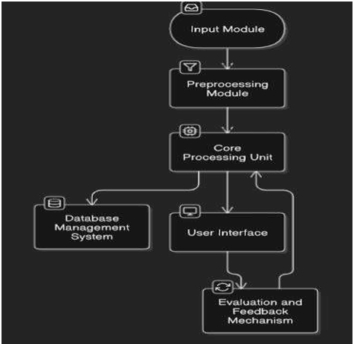

* 1. **Requirement Specification**

### ****4.4.1 Hardware Requirements:****

❖ **Computer/Server** – Required for data processing, model training, and system deployment.  
❖ **Wearable Device (Optional)** – Smartwatch or fitness tracker for real-time data collection.  
❖ **Storage** – To store user activity logs, health metrics, and machine learning models.  
❖ **Internet Connectivity** – For API integration (Google Fit, Fitbit) and cloud-based analytics.  
❖ **Smartphone (Optional)** – For mobile-based tracking and user interface access.

### ****4.4.2 Software Requirements:****

#### **❖ Programming Languages:**

⮚ **Python** – Primary language for data processing, machine learning, and visualization.

#### **❖ Libraries and Frameworks:**

⮚ **Pandas & NumPy** – For data handling and numerical computations.  
⮚ **Matplotlib & Seaborn** – For data visualization and graphical insights.  
⮚ **Scikit-learn** – For implementing machine learning models and predictive analytics.  
⮚ **TensorFlow/Keras** – For deep learning-based activity recognition (if applicable).  
⮚ **Flask/Django** – For developing the web-based fitness dashboard.  
⮚ **Requests & API Libraries** – For integrating with external health platforms like Google Fit & Fitbit.

#### **❖ Development Environment:**

⮚ **Jupyter-Notebook** – For model development and data exploration.  
⮚ **VS Code / PyCharm** – For backend development and application deployment.  
⮚ **PostgreSQL / SQLite** – For database management and storing user data.

**CHAPTER 4**

**Implementation and Result**

* 1. **Snap Shots of Result :**

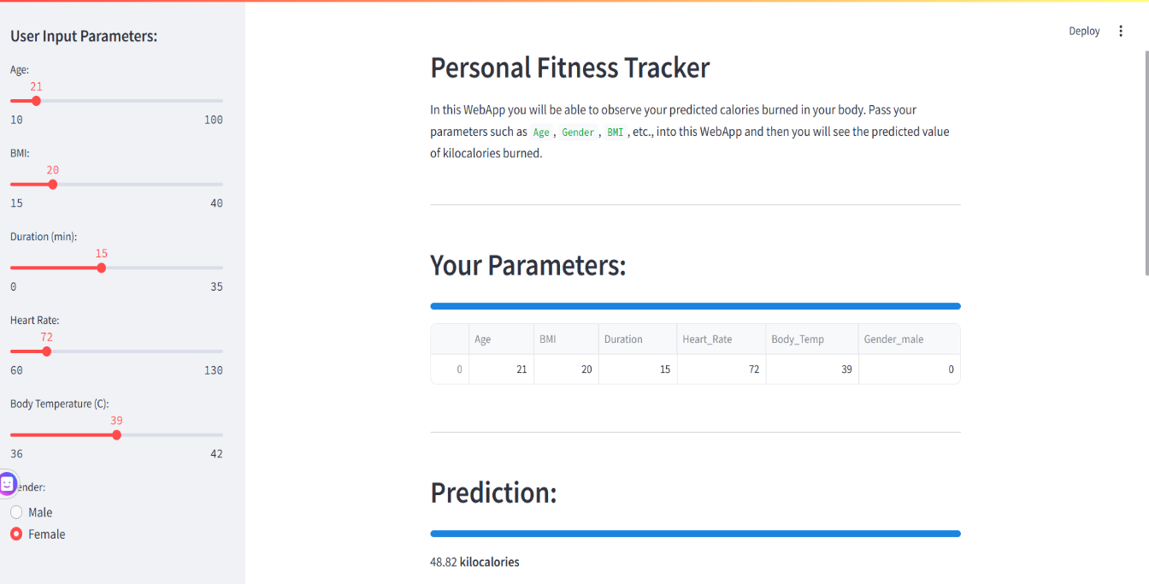

**Figure 1 - HOME PAGE**

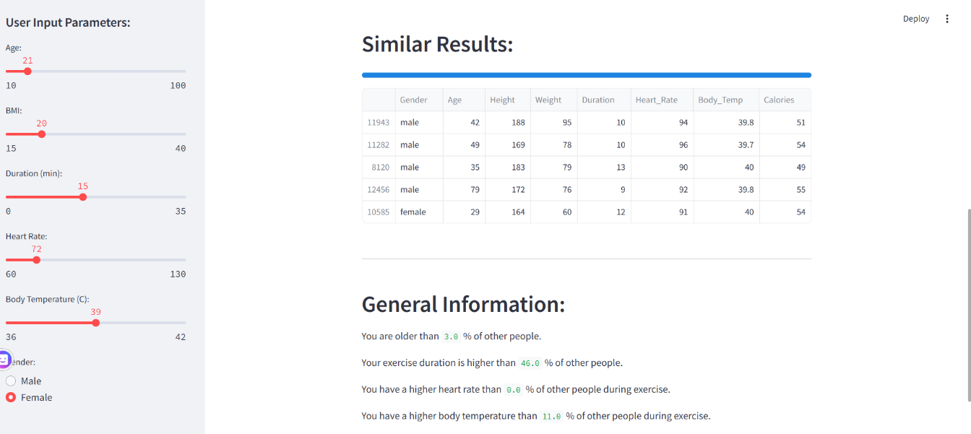**Figure 2 - Similar Results page**

* 1. **GitHub Link for Code :**

https://github.com/kavya-09-pixel/Implementation-of-Fitness-tracker-using-python

**CHAPTER 5**

**Discussion and Conclusion**

* 1. **Future Work :**

**1. Economical Hardware Solutions**

* Integration with low-cost wearable devices such as low-end fitness bands or smartphone sensors to monitor movement and heart rate without the need for costly hardware
* Creation of AI-based fitness tracking apps that utilize camera-based posture monitoring for workout tracking, which does not require special devices.
* Utilization of open-source platforms such as Raspberry Pi to create low-cost, real-time fitness tracking systems for research and community health purposes.

**2. AI-Based Personalized Coaching**

* Deployment of AI-powered chatbots and virtual fitness coaches to offer real-time feedback, exercise corrections, and encouragement based on user performance.
* Machine learning algorithms that learn and improve fitness suggestions based on individual improvement over time.

**3. Deep Health Insights and Forecasts**

* Extending tracking features to stress levels, hydration tracking, and oxygen saturation (SpO2) through AI-based pattern recognition.
* Predictive health analytics for identifying early signs of fatigue, overtraining, or possible health hazards based on user activity patterns.

**4. Gamification and User Engagement**

* Embedding rewards, challenges, and social elements to encourage motivation and workout regularity.
* Creating AI-driven goal-setting tools that dynamically adjust fitness plans depending on user compliance.

**5. Improved Nutrition and Wellness Tracking**

* AI-driven eating tips based on fitness objectives, body type, and activity levels.
* Integration with food diary apps and nutrition databases to monitor macronutrients and hydration.

**6. Cross-Platform Integration**

* Smooth integration with Google Fit, Apple Health, and third-party fitness APIs for a unified health-tracking experience.
* Multi-device synchronization development to allow users to monitor fitness data across smartwatches, phones, and web platforms.
  1. **Conclusion:**

The Personal Fitness Tracker project has a substantial impact on health and wellness as it allows individuals to track and enhance their fitness levels efficiently. With real-time tracking of steps taken, calories consumed, heart rate, and sleep patterns, the system facilitates users to make informed decisions regarding their health. Machine learning-based personalized recommendations further promote user interaction and provide tailored workout and dietary advice based on specific goals.

This project also supports accessibility and affordability through an open-source option for costly commercial fitness trackers. It is backed by wearable devices, smartphone sensors, and external APIs, making it an effortless and user-friendly experience for diverse users. The tracker also promotes healthier behaviors, goal-driven training, and enhanced lifestyle management, leading to long-term wellness and disease prevention.

In addition, the project provides a basis for continued innovation in AI-driven fitness tracking, such as predictive health analytics, virtual coaching, and richer health insights. By closing the gap between technology and personal health management, this fitness tracker presents a scalable, smart, and data-driven solution for individuals aiming to lead an active and healthy lifestyle.

**REFERENCES**

1. Kaggle Fitness Data Analysis - https://www.kaggle.com/fitness-tracking
2. Fitbit Developer API - https://dev.fitbit.com/
3. Machine Learning for Health Applications - IEEE Research Paper